Welcome to King Cougar Wrestling & Naples Wrestling Club Training Center
Our Goal: To provide Beginner, Moderate, and Advanced Conditioning and Wrestling Training to our community. We will have classes for Youth, Teenagers, and College Athletes. We want to build character and well-disciplined athletes who enjoy the competitive nature of wrestling. Over the Last 5 Years King Cougar & NWC has helped train 8 State Champions, 21 State Placers, and over 35 State Qualifiers from all over Southwest Florida. This past year we had 9 Athletes who will be attending various wrestling Universities that trained with us last summer. They earned over $900,000 in scholarship money over 4 years.
Location: Fairways Trade Village - 6561 Taylor Rd #7, Naples, FL 34109
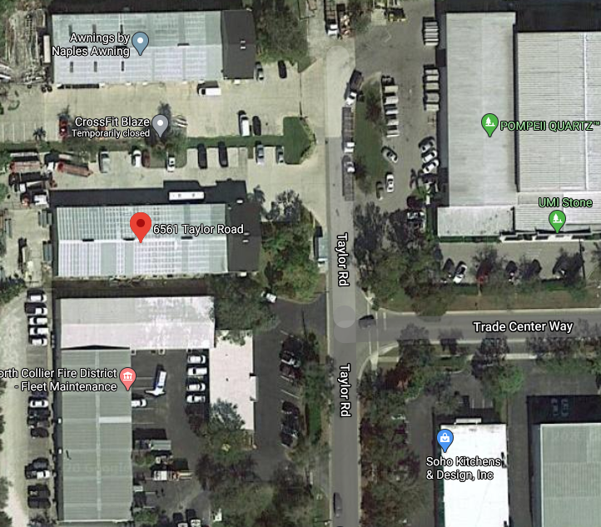
Membership Requirements:
- Membership Facility Collection Fee
  - High School, Middle School, & Advanced Youth – Monday and Wednesday 4:30pm- 6:00pm
    - Drop in Fee @ $15
    - Option A: Monthly @ $100 per month
    - Option B: Quarterly @ $270 for Three Months
    - Option C: Yearly @ $1000 for full Year
  - Beginners Ages 4-7 years – Tuesdays and Thursdays from 5:30pm – 6:30pm
    - Option A: Monthly @ $100 per month
- AAU Membership Must be Up To Date See Below to see how to get an extended Coverage (AB) Use Team Code WYDT7C for Naples Wrestling Club. Ensure you choose “Extended Coverage (AB)”. AAU runs from August to August, so please confirm you don’t have one with coach before buying a new membership. Go to https://aausports.org/Join-AAU.
- Proper Gear and Clothing: Suggested Clothing is Long sleeve and long training Pants (Tights lightweight), wrestling shoes, mouth piece, towel, wipes, and headgear. Make sure you are keeping up with proper hygiene before entering the practice facility.
- Keep all Equipment Clean and use disinfectants. This includes washing your shoes, headgear, and knee pads. Mats will be disinfected prior to and after each session.
- Temperature, Hygiene, and Skin Tests will be required every training session. If you are sick, have active skin infections, etc… you will not be able to practice until you are non-contagious.
- You assume all Liability and risk associated with contact sport. King Cougar Wrestling, Naples Wrestling Club and/or Fairways Trade Village is not responsible for Infections and injuries. Your Membership card is a supplemental insurance policy. Please educate how to use this insurance policy and claims.
- We are a Drug Free, Alcohol Free, Tobacco Free, and Vape Free Non-Profit organization that is intended to offer a safe and disciplined facility for athletes to train. At any time we have the right to revoke your membership and remove you from our facility for any of the following: misconduct, late payment, discrimination, and misrepresenting our organization.
- How do we use your payments? The money collected is used to operate the financial obligations of our lease, utilities, cleaning products, training gear, and administration fees.
We encourage active community fundraising so we can bring in world class guest instructional and motivational members to our club. Our plan is to bring in World Class Coaches and Athletes to provide small group training. In order to bring such champions to our facility we will have to compensate their travel, time, food, and accommodations. Over the years Collier County has had Dan Gable, Jordan Burroughs, Mark Shultz, Obi Blanc, Bo Nickal, Montez Montez, Max Dean, Yianni Diakomihalis, Ben Darmstadt, Max Dean, Chase Singletary, and other amazing wrestlers and coaches to provide clinics. We want to be able to provide the same instructors at our latest facility.
- Compete: We encourage our members to seek out and compete in local, state, and national tournaments in both AAU and USA Events. The more you compete the better you can test your skill level and improve your wrestling skills. We don’t think winning is everything. We want athletes to learn how to enjoy competition in both wins and losses. We learn the most about our training and selves in both winning and losing. We strive to build leaders in our community who uphold character both on and off the mat.

Member Information
Member’s First Name: | First Name
Member’s Last Name: | Last Name
Member’s Age, Grade: | Age, Grade
Member’s Birthdate (MM-DD-YY):
Member’s School: | Athlete School
Membership Plan (Choose options above): | Choose an item.
Member’s AAU Membership Code: | #X#X#X#X
Membership Start Date: | Start Date
Membership End Date: | End Date
Member’s Phone Number: | 0000000000
Member’s Email: | Athlete Email
Member’s Street Address: | Athlete Street Address
Member’s City, State, Zip Code: | City, ST, 00000
Parent or Guardian First and Last Name:
Parent or Guardian Relation (Father, Mother, etc):
Parent or Guardian Phone Number: | 0000000000
Parent or Guardian Email: | Parent/Guardian Email

Naples Wrestling Club Waiver and Release from Liability
1. I, Athlete first and last name , the undersigned, on behalf of myself, my heirs and next of kin, personal representatives, agents, insurers, successors and assigns (all hereinafter “Releasors”) hereby FOREVER RELEASE, DISCHARGE AND COVENANT NOT TO SUE THE Naples Wrestling Club INC or King Cougar Wrestling INC., or their affiliated clubs, administrators, agents, directors, officers, state organizations, members, committees, volunteers, all employees of AAU, and any and all participants, officials, referees, coaches, host clubs, sponsoring agencies, sponsors, advertisers, local organizing committees (and if applicable, owners, lessors and operators of premises used to conduct any Wrestling event, meet, practice or activity (all hereinafter “Releasors”) from any and all liabilities, claims, demands, causes of action or losses of any kind or nature, past, present, or future, direct or consequential that I may hereafter have for PERSONAL INJURY, PERMANENT, TEMPORARY, TOTAL OR PARTIAL DISABILITY, DISFIGUREMENT, PARALYSIS AND ANY OTHER LOSSES OR DAMAGES TO PERSON OR PROPERTY OR DEATH, arising out of participation in, attendance at or traveling to and from any Naples Wrestling Club or King Cougar Wrestling event or activity including, but not limited LOSSES CAUSED BY [PASSIVE OR ACTIVE NEGLIGENCE OF THE RELEASES, or hidden, latent or obvious defects in the facilities or equipment used.
2. Releasor understands and acknowledges that Naples Wrestling Club or King Cougar Wrestling activities and the sport of wrestling in general have inherent dangers that no amount of care, caution, training, instruction, supervision or expertise can eliminate. RELEASOR EXPRESSLY AND VOLUNTARILY ASSUMES ALL RISK OF PERSONAL INJURY, PERMANENTLY, TEMPORARY, TOTAL OR PARTIAL DISABILITY, DISFIGUREMENT, PARALYSIS AND ANY OTHER LOSSES OR DAMAGES TO PERSON OR PROPERTY OF PASSIVE OR ACTIVE NEGLIGENCE OF THE RELEASEES, or hidden, latent or obvious defects in the facilities or equipment used. 3. Releasor acknowledges and fully understands that each participant in any King Cougar Wrestling event, meet, practice or activity, including Releasor, will be engaging in activities that involve risk of serious injury, including permanent, temporary, total or partial disability, disfigurement, paralysis and any other losses to person or property including death, and that severe social and economic losses may result not only from Releasor's own actions or negligence, but from the actions, inactions or negligence of others notwithstanding the rules of play or the condition of premises or of any equipment used. Further Releasor acknowledges and fully understands that there may be other associated risks with such activities which are not known or not reasonably foreseeable at this time.
I ACKNOWLEDGE THAT I HAVE SUFFICIENT OPPORTUNITY TO REVIEW THE PROVISIONS OF THIS DOCUMENT AND UNDERSTANDS ITS PURPOSE, MEANING AND INTENT.
Participants Signature: | Date: Enter a Date
Print Name (Participant): Printed First and Last Name
The undersigned, __________________________________________________ does hereby represent that he/she is, in fact, the parent or legal guardian of ________________________________________ and acting in such capacity agrees to the terms and conditions of the above stated waiver and release.
 |  | Click or tap to enter a date.
(Signature of parent or legal guardian) |  | (Date)
Printed First and Last Name |  | Relationship
(Print Name) |  | (Relationship to minor)

